Andre Francavilla

Poison dagger software

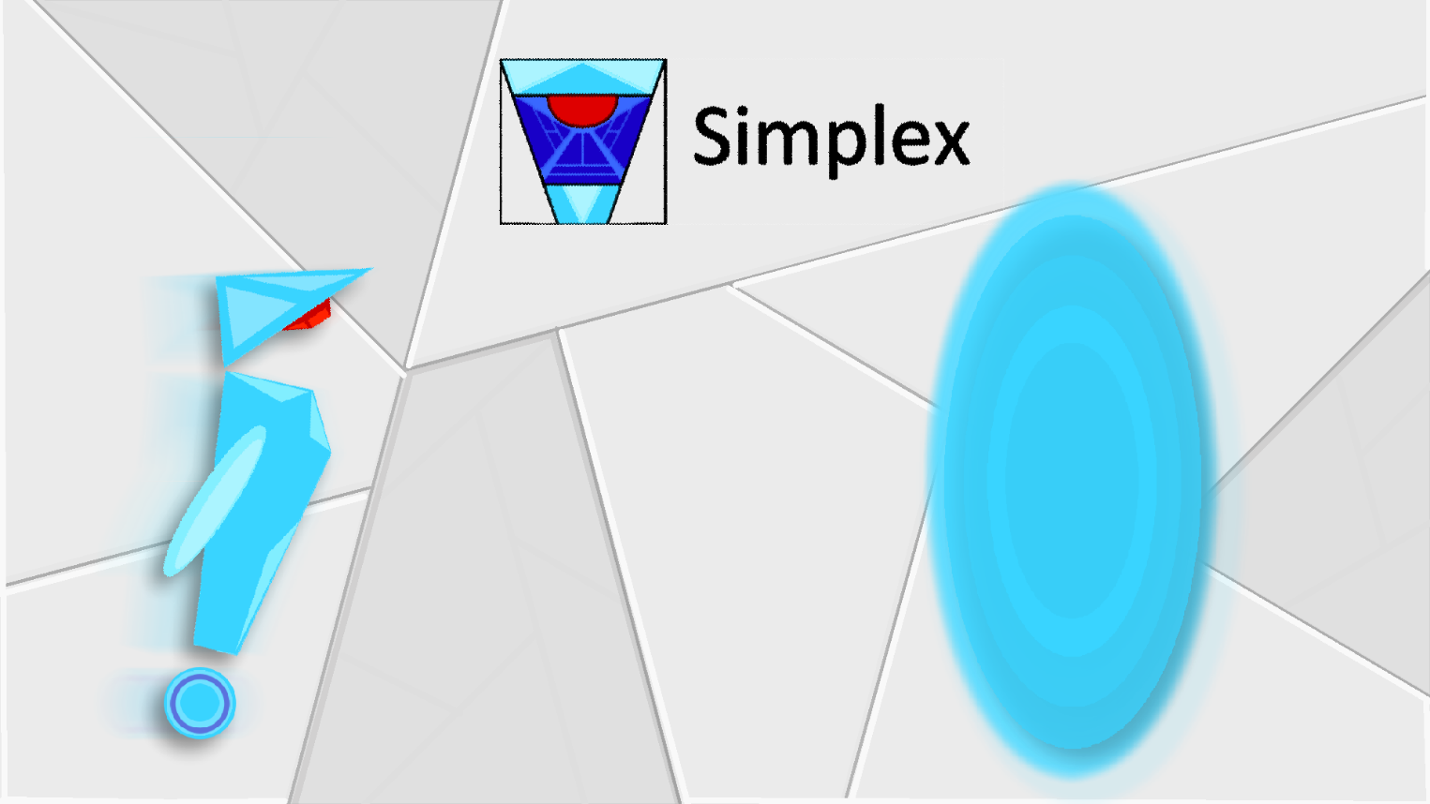

**Game Design Document**

**Simplex**

Game Design Document

**General Info**

* **Title**: Simplex
* **Genre**: Puzzle
* **Software** **Used**: Unity3D, Krita, JuiceFX
* **Style**: 2D, minimal
* **Recommended** **Age**: 12+
* **Target** **OS**: Android

**Overview**

Simplex is a videogame that aims towards an innovative and intuitive design that consists in simple shapes, colours and the absence of any type of text. The player will be guided by his own intuition and the game’s mechanics will be indirectly taught to him as he proceeds. The discovery of the game and how it works is part of the puzzle itself, encouraging the player to further immerge himself into the needed mindset. The game’s main mechanics revolve around keys, locked doors, buttons, pressure pads, laser beams, laser receivers, reflective objects and gravity shifters.

**Description**

The player controls the main character through touch screen controls, which are relatively a ‘left arrow’ to move left and ‘right arrow’ to move right, placed on the bottom left of the screen; a ‘circle’ button to jump, placed on the bottom right and an interact button composed by an animated circumference that appears above the player’s head. The levels resemble a platformer, characterized by a monochromatic colour palette. When the game begins, right after the player presses the start button, he is presented to a really simple tutorial that starts with a flat level with a portal in front of him. He will soon understand what buttons allow him to move and what is the game’s main objective. Afterwards, he will be presented another tutorial level that contains a lifted terrain that blocks him from reaching the objective; forcing him to learn how to jump. Further on, the levels will introduce more and more game mechanics gradually, integrating the game’s tutorial section flawlessly with the rest of the levels.

Table Of Contents

Main Menu 1

Appearance 1

Navigation 1

Menus 1

• Home Menu 1

• Settings Menu 2

Other Menus 2

Colour Codes 3

The Player (Simplex) 4

Story 4

Appearance 4

Controls 4

Abilities 4

• Interact 4

Main Camera 5

Behaviour 5

Level Items 5

Main Objective 5

Locked Door 5

• Linked Objects 5

Key 5

Button 6

Weight Cube 6

Pressure Pad 6

Laser Emitter 7

• Laser Beam 7

Laser Receiver 7

Mirror 7

Simplex Command Center 8

Gravity Switcher 8

# Main Menu

## Appearance

Due to the fact that the game consists in no text whatsoever, the main menu’s appearance relies solely on symbols and basic shapes. The background must be a bright tone of grey that is pleasing to the eye, while the symbols and icons are filled with desaturated colours and are chosen to specifically communicate different kinds of information to the player. Green indicates something safe; blue indicates information and knowledge, red indicates danger […].

(more info about colour codes here)

## Navigation

The navigation of the main menu relies upon intuition and the player’s past experience. It relies, for example, upon the common knowledge that a triangle that’s pointing to the right is the play button and that the symbol of a gear resembles the settings menu. Navigation occurs through touch-screen input with the use of UI Buttons and simple sliders, organized to indicate as clear as possible what their actions are and what they’re used for.

## Menus

There are only 2 menus present in the Main Menu, which are the **Home Menu** and the **Settings Menu**.

### Home Menu

* The home menu is the first menu that shows up after the starting splash screen(s) and it’s the first screen in which the player can interact with the game. It consists in the game’s icon positioned at the top-middle area of the screen and 3 buttons, positioned at the centre of the screen: the *Quit button*, which is a big red ‘X’; the *Settings button*, resembled by a grey gear and the *Play button*, resembled by a green triangle that’s pointing towards the right.

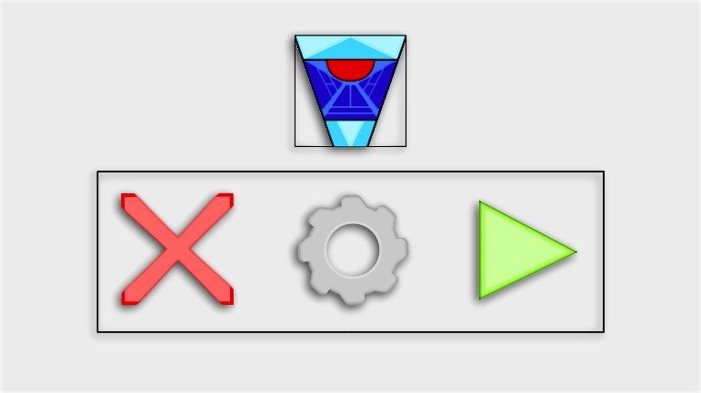

### Settings Menu

* The settings menu is shown to the player once he presses the ‘Settings’ button in the Home Menu screen. It consists of a simple volume slider and a ‘Reset Save Data’ button. The ‘Reset Save Data’ button allows the player to eliminate all progress achieved in the game and start over. Its icon is a floppy disk getting shredded.

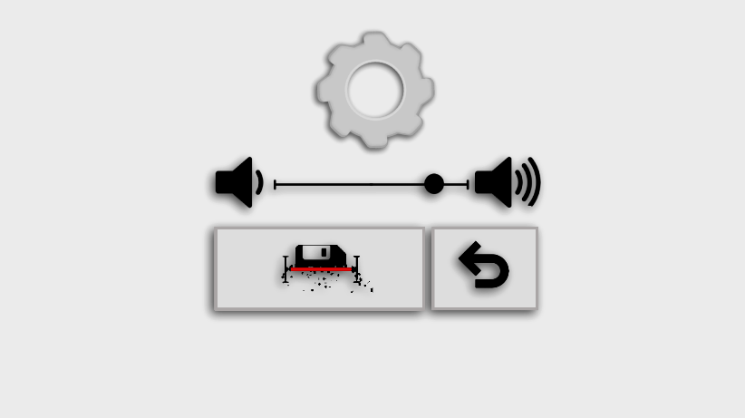

# Other Menus

* **Pause Menu**
  + The game also presents a Pause Menu that can be accessed from the game’s interface. From the pause menu, the player can return to the main menu or return to the game. The pause menu contains an “Exit” button that has an icon of a stylized emergency exit and a “Return to game” button that has an icon of a black ‘X’.

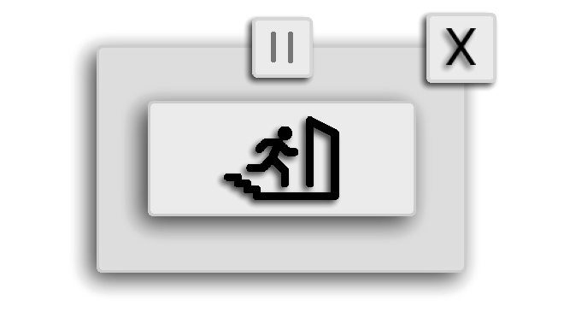

# Colour Codes

Simplex uses specific colours to communicate specific things. It is really important to keep track of what colours and hex codes correspond to within the game. For this reason, there’s a table below with all the used colours in the game.

(Colour names gotten from ‘[Name that Colour](http://chir.ag/projects/name-that-color/#FFFA39)’)

|  |  |  |  |  |
| --- | --- | --- | --- | --- |
| Colour Name | Hex Code | RGB Value | Description | Sample |
| Silver |  |  | World |  |
| Gallery |  |  | Background |  |
| Dodger Blue |  |  | Objective |  |
| Green Yellow |  |  | Interactable |  |
| Red |  |  | Hazard |  |
| Golden Fizz |  |  | Collectible |  |
| Heliotrope |  |  | Special |  |

# The Player (Simplex)

## Story

The main avatar’s name is Simplex. The idea is that Simplex has to transfer a sense of empathy to the player due to his human aspects, making the player realize how lonely Simplex is in a world full of puzzles. As a matter of fact, the objective is to solve every puzzle to try and reach something, but this something is never actually a clear vision; it’s more of an idea that to survive, the player must keep solving puzzles for the rest of his life.

## Appearance

Simplex’s appearance resembles a humanoid robot with a metallic finish. His head, body, arm and wheel are held together by magnetic energy. The head and the arm will have to be able to move dynamically, allowing the character to look at objects and give hints to the player.

## Controls

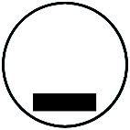The player will be able to control Simplex through the User Interface. There are only three buttons that control the character, which are respectively:

* **Left Arrow**: moves the character left
* **Right Arrow**: moves the character right
* **Dot**: jump

## Abilities

### Interact

Simplex’s main ability is ‘interacting’. Simplex can interact with weight cubes, buttons and magnetic command objects when he’s within the Simplex Command Centre. Interacting occurs when the player presses the ‘Interact’ button that appears above Simplex’s head when he’s near something that is interactable.

# Main Camera

## Behaviour

The Main Camera in Simplex is not static, it must behave in a specific way and manner. The player is centred on screen and the camera follows him with a smooth delay effect to it. The camera must always follow the main character, no matter what situation he might be in.

# Level Items

## Main Objective

The main objective is a portal that teleports the player to the next level. Whenever the player touches the portal, he gets sucked into the core in a similar fashion to how black holes attract light. The player will get to know that the portal is the main objective through the very first tutorial level of the game, where the player is simply asked to move right, towards the portal.

## Locked Door

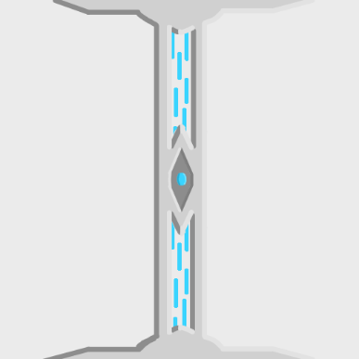The ‘Locked Door’ is the main level item that allows the player to proceed within the puzzle. These doors don’t allow the player to access certain parts of a level until it is unlocked. Locked doors can be unlocked permanently with a key, temporarily with a button press or it can stay unlocked until the linked pressure pad has a weight cube on it.

When a locked door gets unlocked, it opens up vertically and stays open depending on the nature of its linked object.

### Linked Objects

A linked object, such as a pressure pad, displays what object it is linked to through a visual key that consists in a dotted pattern that goes from one end (e.g. Pressure Pad) to another (e.g. Locked Door).

## Key

They key is a collectible object that the player can use to unlock any locked door. Once a locked door gets unlocked with the key, the key is no longer utilizable. The player can hold only one key at a time.

When the player touches the key, a visual hint illustrates that the item has been collected by the player. When the player is carrying the key, the item is visualized on the left side of Simplex and does not flip with the character.

## Button

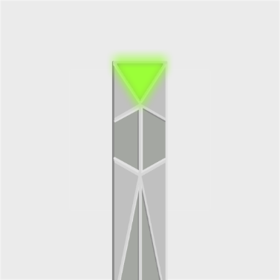The button is an interactable that the player can utilize to unlock a door temporarily. This means that when a button is pressed, a locked door that’s linked to the button unlocks and stays unlocked until the timer runs out.

When the player stays in front of the button, the Interact Button will appear above the player’s head. The ‘Button’ gets activated when the player presses the Interact Button, unlocking the linked door and starting a timer that counts to zero. The timer is not visible to the player; instead, the time remaining before the door will close will be communicated to the player through a ticking sound and the button’s light will alternate its active state upon each tick.

## Weight Cube

The weight cube is an interactable that the player can interact with. It’s a square shape that is affected by physics and that the player can push around. The player can also pull the cube if he is near it (and not touching it) and presses the Interact Button. If the player is pulling the cube, he can let go of it by jumping or by pressing the interact button again. The interact button appears only when the player is near the cube or when the player was already pulling it but then stands still.

## Pressure Pad

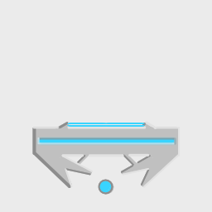The pressure pad is considered an objective item because it must be activated to proceed within the level. It is a horizontal pad that activates when a weight cube is positioned on top of it and it deactivates when the weight cube is no longer on top of it. When it is activated, a locked door that is linked to the pressure pad will unlock; when it is deactivated, the locked door, if it was previously unlocked, will be locked again.

## Laser Emitter

The laser emitter is a special object because it emits a deadly *laser beam* in the direction the emitter is facing. Laser emitters can be positioned on walls, floors and ceilings. The laser emitter is turned on by default and can be turned off only with a button or a pressure pad; unless the player positions a weight cube in the beam’s trajectory.

### Laser Beam

The laser beam is a hazardous object because it can instantly kill the player when he touches it. The laser beam extends from the laser emitter’s origin all the way to the object it collides with, unless it is a *mirror*. Laser beams can intersect with each other without conflicting with each other’s direction.

## Laser Receiver

The laser receiver is an objective item because it can be activated to proceed within the level. The laser receiver is activated when a laser beam is hitting it and it is deactivated when there is no interaction with any laser beam.

When the laser receiver is activated, it unlocks a locked door and keeps it unlocked for as long as it is activated.

## Mirror

Mirrors are objects that you can interact with and are used to solve more complex laser puzzles within levels. They are pre-positioned within the level in a way that the player must interact with them to solve the puzzle. When a laser beam hits the surface of a mirror, the beam gets reflected, altering its path. A mirror can reflect laser beams only if the laser is touching the mirror's glass.

When the player is within the *Simplex Command Centre*, he can rotate the mirrors by touching them. Every time the player touches a mirror, it will rotate 45 degrees on itself.

## Simplex Command Center

The Simplex Command Center is a special object that allows the player to interact with *mirrors*. Due to the fact that the mirrors in a section of a level aren’t always visible to the player and are sometimes out of reach, the player wouldn’t normally be able to visualize the laser puzzle and solve it. The Simplex Command Center addresses this issue by making the player enter an “edit” mode when he interacts with it; making the camera focus on the laser puzzle, zooming out if necessary.

The player can exit edit mode by pressing the “X” button that appears on the command center when the player is in the mode.

## Gravity Switcher

The gravity switcher is a special object. Whenever the player interacts with it, the gravity of all physics-based objects change direction, including the player. When the player is within the gravity switcher’s interaction range, the “interact” button will appear above the player’s head. When the player presses the interact button, the gravity switcher will give a visual hint of the gravity’s current state by pointing its internal arrow in the direction gravity is at.